Davis DeRodes and Lewis Pipkin

QTM 345

May 2nd, 2017

Vindicating Morrey: The 3-point Attempt Rate and Predictors of Wins in the NBA

**INTRODUCTION**

Basketball has grown over the years to be incredibly popular and ingrained in

culture, American and otherwise. Its popularity is seemingly at its peak right now,

especially in the United States and China, and the NBA is the sport’s leading league in

the world. Athletes all over the world dream of playing in the United States for one of

our thirty teams, and this year, the league had players from 41 different countries,

including Italy, Croatia, Austria, and South Sudan.

As the league grows and changes, the playing style adapts to incorporate new,

innovative ideas and play styles. Partner this with the growing analytics movement in all major sports (spurred by Billy Beane, general manager of the Oakland Athletics baseball team in the late 1990s), and we see strategies changing on and off the court. Instead of teams taking the players they have and molding a play style to accentuate their strengths, several teams are now looking for certain archetypes of players to fit their preferences or better complement their superstar player(s), if they are lucky enough to have one. Take the Toronto Raptors: by modern standards, their play style is as old as their mascot. For the past 6 years, the Raptors have been bottom 10 in the league in number of possessions per game. They slowly chip away at their opponents, and their strategy is typically to give the ball to their star, DeMar DeRozan, and let him wind down the shot clock and end possessions with a midrange jumper. We can clearly see this in figure one, which is a shot chart of Raptors 2016-2017 season.

Then, there are the Houston Rockets. The Rockets have made a revolutionary

change in strategy this year: shoot 3-pointers, dunks, and layups, and that’s it. Midrange shots are an aberration, and should be avoided due to their relative inefficiency. Layups and dunks are highly efficient shots, as they are very hard to miss: in 2017, the league

average shooting percentage on dunks and layups was 63.1%, meaning that for every dunk or layup attempt, teams gained an average of 1.26 points. The league average on midrange jumpers, however, was 41.2%, meaning teams gained only .82 points per shot in expectation. Clearly, dunks and layups are the better, more efficient option. League average 3-point shooting percentage was 35.8%, so teams gained about 1.07 points per 3-point shot. They’re harder to make, but each individual shot gives teams more points in expectation which explains why some teams have been letting the 3-pointers fly at increasingly higher rates in the name of efficiency. One can see the jarring comparison between the Raptors’ and more analytical Rockets’ shot charts (see figure 2) as the Rockets have almost no midrange shots in their shot chart and a barrage of 3’s and points in the paint.

With the knowledge of the added efficiency given from 3’s and points in the paint, the Houston Rockets completely retooled their roster from the year before, giving their star now point guard James Harden the reigns to drive for layups and pass the ball out to one of the four high-percentage shooters outside of the arc if his path is too congested. This system, built under GM Daryl Morey, a statistician, graduate of Northwestern and MIT, and co-founder of the MIT Sloan Sports Analytics Conference, has become wildly successful, as the Rockets shot up to third place in the NBA this year. Putting together Morey’s analytical mindset, Harden’s intelligence and skill, and coach Mike D’Antoni’s love for efficient offense has revolutionized the NBA.

Morey’s philosophy of the game has unquestionably ushered in a new era of basketball quantified mostly by a higher attempt rate of 3 pointers and an increase pace. In model 1 listed below, we can clearly see that since Morey has entered the NBA the attempt rate of 3 pointers has increased dramatically and statistically significantly. Along with the 3-point attempt rate, teams have also been playing with more pace since Morey has entered the NBA (model 2). The interesting insight is that the 3-point attempt rate has an incredibly large and significant relationship with pace. Fundamentally, the number of 3-pointers should be independent from the number of possessions in a game. Now that the “MoreyBall” is rolling, we would like to assess in this paper if taking more 3-pointers and playing with a faster pace will actually lead to more wins. Essentially, we are separating the philosophy from the man. The Rockets have a top tier NBA culture, which effects an insurmountable number of outcomes including player satisfaction, player selection, etc. We want to answer “If the Kings (a perennially bad franchise) started playing like the Rockets tomorrow, would it work?”.

**LITERATURE REVIEW**

Yang (2015) discusses the importance of a team’s average PER (player efficiency rating) in predicting that team’s win ratio. PER is a weighted average of a cornucopia of measured statistics on a player including mostly offensive statistics, rebounds, steals, and blocks. What is troubling about Yang’s analysis is that the entire analysis is predicated on this one variable. While this yields a high R2, there are certain to be more factors that affect team performance. For example, PER only uses steals, blocks, and rebounds as a representative of defensive performance and ignores RPM (Real Plus Minus), which is generally regarded as a measure of a player’s impact outside of the stat sheet.

Csataljay (2009) studied the European Basketball Championship in 2007, held in Spain. This study found that, in this certain tournament with 54 games in total, most counting stats (including field goal percentage, free throw attempts, and of course, points) were significantly higher for the winning team than the losers. For close matches (where the margin of victory is single-digit), the most important factors were free throw percentage and rebounds. This study’s analysis, however, is specific to one tournament in Euroball, and is fairly rudimentary: it involves only comparing confidence intervals of different clusters of games.

An already established model for predicting wins is Fivethirtyeight’s CARM-Elo (Career-Arc Regression Model Estimator with Local Optimization) ratings. The name is a play on the existing Elo rating system used in many major sports, but is also named after the New York Knicks’ Carmelo Anthony. CARM-Elo takes into account the individual information about each player on a team, as well as factors such as fatigue, travel, and altitude. CARM-Elo is a dynamic model, updated after every single game in the NBA season. The predictions at the beginning of the season are not the end goal; it is the result of each individual game that this model aims to predict.

**DATA ANALYSIS AND DISCUSSION**

The data for this project came from basketball-reference.com, a site that

aggregates all data for every single game since the inception of the NBA. The dataset we

compiled contains 34 variables, most of which were used only in preliminary

analyses; only a handful of them are in the final models. The most important variables are *Wins, Age, Pace, 3-point attempt rate, 3-point shooting rate, 2-point shooting rate, Total Rebounds, Turnovers, Steals, Blocks, and Personal Fouls.*

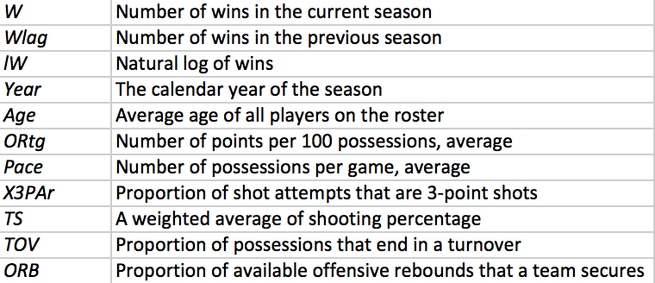

These are the variables that ended up being the most important in predicting wins

both with regards to model fitting and causal inference.

Each of the models that are

used in this paper are fixed effects models. Our reasoning for using fixed effects to build

this predictive model is that there are certain unquantifiable effects that play into a team’s

success: coaching, team culture, team location, whether or not

the team is ‘tanking;’ that is, intentionally trying to lose games in order to get a high draft

pick for the upcoming draft, among many others. Regardless, there are several features of

teams that generally stay generally consistent from year to year at least in the mid 2000’s

to now.

Team culture is said to be one of the most important things to a team’s success. For example, some of the perennial bottom-feeders of the NBA (Sacramento Kings, Orlando Magic, New York Knicks) are publicly dysfunctional. On February 7th, 2017,

Sacramento’s general manager, Vlade Divac, publicly quashed the trade rumors that had

surrounded their superstar player, DeMarcus Cousins, for the past two years: “We are not

trading DeMarcus Cousins. We hope he’s here [in Sacramento] for a long time.” On

February 20th, however, Cousins was traded to the New Orleans Pelicans. Trade rumors

also surround the Knicks’ Carmelo Anthony, whose team president Phil Jackson said will

be traded during this offseason. It’s no surprise that these teams have each averaged

around 30 wins per season for the past four years. There are teams with winning cultures

as well, however; the San Antonio Spurs have won at least 50 games in every season

since 1997 (with one exception, a shortened 1999 season, in which they won 37 games

out of 50 played; San Antonio won the championship that season).

San Antonio has had an unimaginable consistency due to the nature of their

players and the values that the management and coaching staff have. In analyses, it would be impossible to quantify the supportive environment of San Antonio or the selfless leadership of Coach Popovich or the franchise’s stars (Tim Duncan, Manu Ginobili, Tony Parker, and Kawhi Leonard) as it would be to model the dysfunction of the Sacramento Kings. Luckily, we are able to avoid the potential omitted variable bias that would result from running a simple OLS by using a fixed effects model.

Figure 3 shows the causal model that we concluded for this project. 3 Point

Attempt rate has two main confounders in our data set: 3 Point Shooting Percentage and

2 Point Shooting Percentage. If a team is particular good at the former and bad at the

later, they might choose to shoot more 3 pointers based off of this information.

With regards to pace, anything that ends a possession and leads to wins would be

a confounder. This includes rebounds, steals, blocks, fouls, turnovers, and making

shots. Also, age is a major confounder for pace as older teams tend not to “run” as much

push the pace as much.

As seen in our fixed effects model, everything is significant at the $\alpha$ = .01

level except for fouls, which is expected as all of these statistics should contribute

to winning a basketball game. Age has a positive effect as once pace is controlled,

veterans are smarter and make better decisions than younger players. 3 Point shooting

percentage and 2 Point shooting percentage both have positive effects on winning as

expected along with rebounds, steals, and blocks. On the negative side, turnovers do have

a negative effect on winning a game.

With regards to 3 pointers attempted a game, it has a very small p-value with a

positive estimate. This suggests that regardless of how the team shoots, a team should

shoot more threes. Finally, pace had a negative estimate with a very small p-value,

implying that given all the factors mentioned a faster game pace might not lead to better

results.

**DISCUSSION AND CONCLUSION**

Using a fixed effects model and controlling for several possibly confounding

factors, we conclude that regardless of a team’s ability to shoot (within reason), a team

should take more three pointers. This conclusion is in direct support of MorreyBall. However, our analysis also concluded that when controlling for several turnover causing factors pace has a negative impact on winning. Although this appears contradictory to MorreyBall, it in fact is not entirely. If a team is to play faster and not get more steals, shoot a better percentage, and not get tired due to old age, then what is the point of playing fast? Our causal graph although conceptually correct is probably incorrect in the fact that pace creates better opportunities for shots, steals, and blocks. Unfortunately, like most things in statistics and basketball it makes analyzing the effect of pace on a team much more difficult. I would conclude then that there’s definitely not evidence suggesting that a team should play fast if it can, but this is not a refutation of it either.

There are some adjustments to be made for this model to

truly be predictive- although we referred to this analysis as predictive during this paper, it

would be more accurate to call these models descriptive. These models are more suited to

knowing what lend themselves more to winning- actually predicting the outcomes of

individual games will prove to be more difficult. We do have an idea of how to go about

building a predictive model, however: it would involve keeping comprehensive statistics

on every team (luckily, basketball-reference.com does this part for us) and fitting a model

for each individual game. This approach could also be used to predict wins for a season

before the season begins, involving lagged values and some measures for individual

players (since every team is at least a little bit different at the beginning of each season).

We believe a good way to predict success would be to

incorporate an instrumental variable for team chemistry. Although it would be hard to

format, quantifying how many of the players have played together

in other contexts (for example, Olympic teams, college teams, or All-Star teams) would

be a fair instrument along with the number of mid-season head coaching fires a team has

had.

Overall, this paper has suggests that MorreyBall is much more than just Morrey

himself, but his ideas, particular shooting more 3-pointers, can be applied to any team.

However, it would of course be better if that team taking more 3-pointers had some

excellent 3-point shooters as well.

**WORKS CITED**

Basketball-Reference.com. Web. 23 Apr. 2017.

Boice, Jay. "How Our 2015-16 NBA Predictions Work." FiveThirtyEight. N.p., 20 Oct. 2016. Web. 23 Apr. 2017.

"Calculating PER." Basketball-Reference.com. Web. 23 Apr. 2017.

Csátaljay, Gábor. "Performance Indicators That Distinguish Winning and Losing Teams in Basketball." International Journal of Performance Analysis 9.1 (2009): 60-66. Web. 21 Apr. 2017.

Yang, Stanley. "Predicting Regular Season Results of NBA Teams Based on Regression Analysis of Common Basketball Statistics." Thesis. University of California, Berkeley, 2015. Print.

**APPENDIX**

Toronto Raptors’ 2016-2017 shot chart

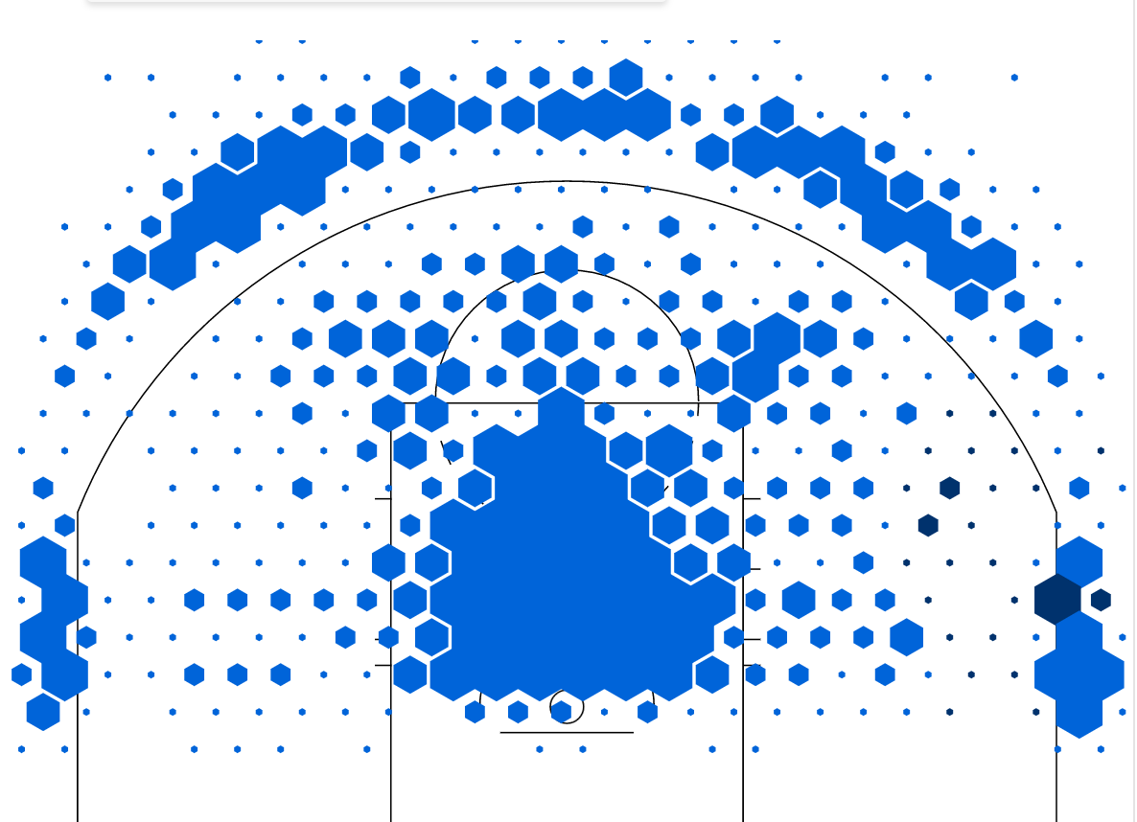

Houston Rockets’ 2016-2017 shot chart

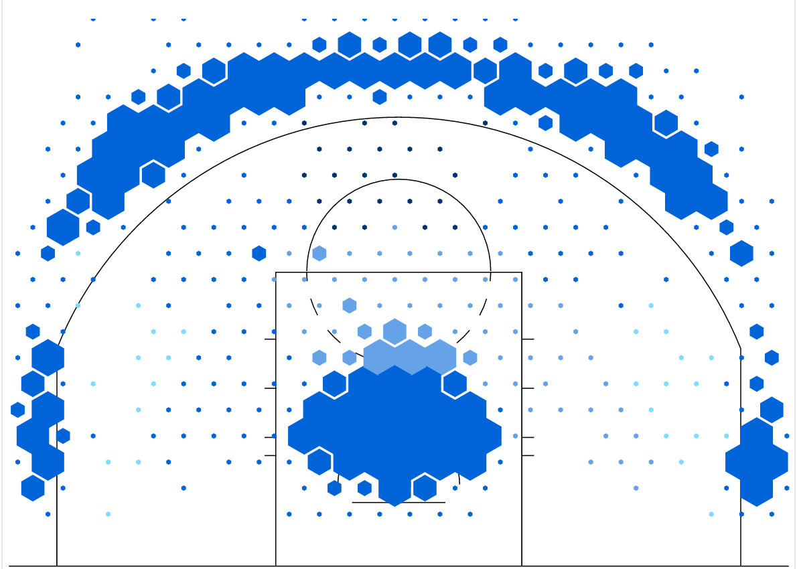

Both shot charts available on StatMuse